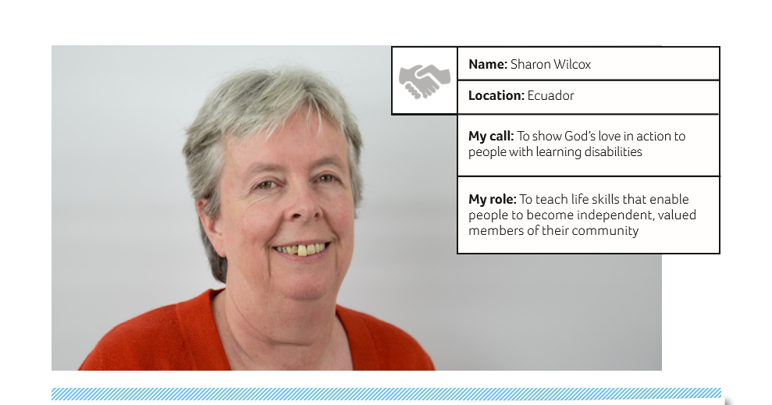

Dear friends,
Thank you for your continued support as we reach the middle of the year. In my last letter, I explained that I have a new role in the church. Well, as the fellowship ministry, we have been busy helping the church to celebrate St Valentine’s/ Friendship Day, Easter Sunday, Mother’s Day (15 May) and the Day of the Child (1 June), making keepsakes, giving out flowers and making 120 jellies. By the time you read this we will have been doing something for Father’s Day too.
Pastor William and the deacons have decided that they want the church anniversary celebrations to follow the same format as previous years, so we have been visiting various locations that have swimming pools, football pitches and covered eating areas big enough for 300 people for the family day on Saturday (18 August). William is looking into holding the Sunday service in a local hotel.
As liaison between the church and the Baptist school, I have managed to persuade Pastor Rodrigo and Pastor Ricardo to cover the weekly assemblies. Pastor Ricardo and his wife (my friend Peri) have agreed to do two or three events in the school during the year as well.
Ricardo and Peri, returned to Santo Domingo at the beginning of March to start an evangelism ministry, having been in the USA for the past two years. You may remember that she and I used to meet for lunch once a week so that she could speak English with someone.
She still speaks very little Spanish. We have begun meeting up for lunch again. I have also helped out with their ministry a couple of times, visiting some of the poorest suburbs, and showing a Christian film. The children have been pouring in once someone passes out word that there is popcorn!
Our fellowship ministry team has visited several people from the church who have been unwell, or have significant problems, to spend time with them, offer a word of encouragement and to pray. On one occasion we visited Pastor William’s grandmother who is 99 years old. From her “sick bed” she was instructing us to sing worship songs, as she wanted to sing. It was an uplifting visit for all of us. She has, over the years, been responsible for bringing many people to the Lord or guiding their walk. William’s father (her son) is also a pastor.
During our month-long holiday in March, I spent time trialling new craft ideas at home. I went to Quito to buy supplies (using money gifted to us), and had a few days visiting Cuenca, Mindo (the Cloud Forest) and Guayaquil (for Petita’s son’s graduation). After six years of studying, he is now a qualified chemist) and we all had a day at the beach. I managed to get burnt, even with Factor 50! As it was rainy season, there had been several landslides around the country, so I thank God for safe travel. Thanks to those of you who were praying for me at that time.
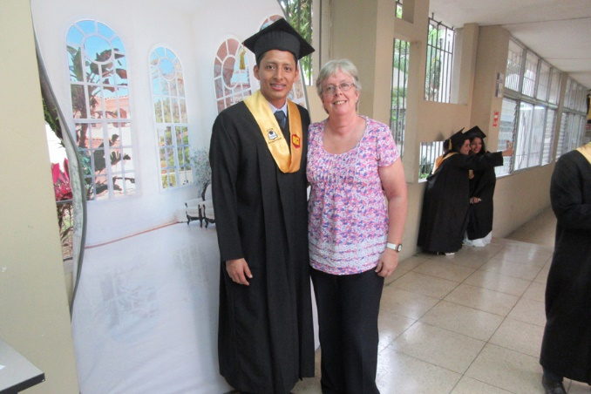Danilo’s graduation
We started the new year of the Life Skills Programme on 2 April. I have found it difficult to explain who and where we are when speaking to people. So, after much thought and prayer, we decided to give it a name.

“The Orchid”
Why this name? Because people with learning difficulties need plenty of love and care in order to grow, just like an orchid.
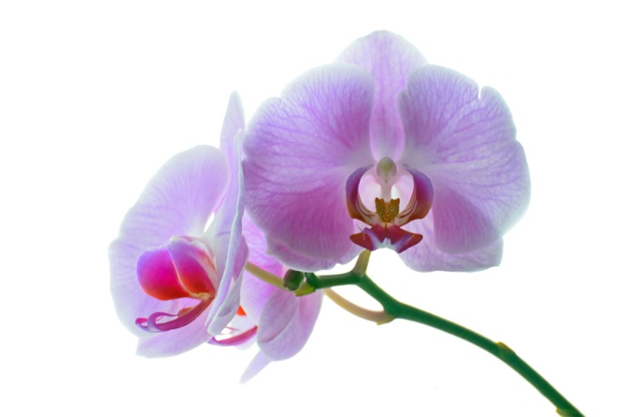Having finished the year with five, we now have seven students. At the beginning of April we received requests to take three more, but after a short trial period it turned out that they were not yet ready to be involved in such a programme as they need to be more physically stimulated in order to release all the energy they have.
However, though it saddened me a little that they wanted to leave where they were, I was delighted to be approached by the families of Jostyn and Washington (my two original students when I started working with Petita in the Foundation Vida en Abundancia), asking if we had a place for them. Of course I said “yes”. I believe that this was God’s hand re-forming the original group which he had chosen for me, as the work with them was not finished. Marlon was my third student in that original group. It has been lovely over the past few weeks to see how their friendships have developed over the past two years – a genuine friendship and concern for one another.
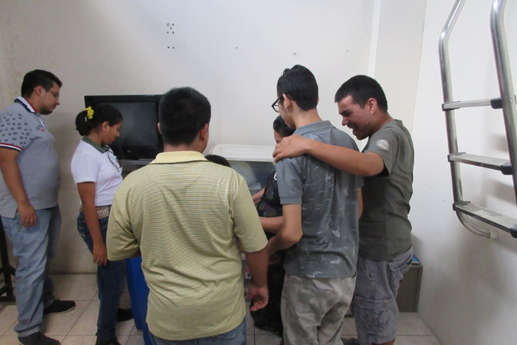 It’s been lovely to see friendships develop so strongly with my original group
I am also delighted that Jostyn still carries the Bible we gave him, and wants to use it. He and Marlon even “fight” at break time over who is going to pray and give thanks for their snacks! We really only need to sow seeds – God does the rest. Jostyn is now 15 and has grown up a lot from the young boy who came to us as a 12 year old with only three months of schooling. He now enjoys learning… most of the time. He is also becoming much better at football these days.
In April, we celebrated Gloria and Javier’s birthdays with the customary cake, jelly and cola. These are always happy events.
Following on from my experimenting during the holidays, we have started a couple of new activities: computers (with a new laptop and a donated one) and gardening. We were invited by Lydia and Mark Trezise (short term CMS people in mission working with CraftAid International) to use a piece of the land that they are renting from the Foundation on the outskirts of town. So every Wednesday we take two buses and currently are growing vegetables, herbs and lavender. Everyone has been involved in preparing the soil, planting seeds and getting very muddy. I don’t think they quite believe that one day they will be able to eat some of what they have planted.
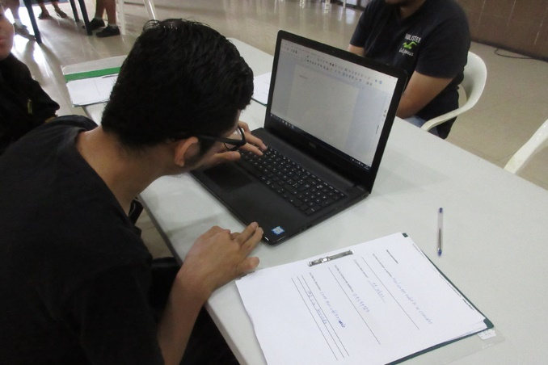Computer studies
We have also changed the things that we make to sell. We have been making body sprays, room sprays, reed diffusers and scented candles, using essential oils. We hope to also decorate canvas bags and make drink coasters in the near future.
We received news that a team of volunteers with Latin Link is coming in July for three weeks, to help build an extension on the church where I work. This should mean that we will have our own space to store things and possibly our own room to work in. I am also personally excited to know that one of the people coming over is from my home church in Thatcham. We are really grateful to Latin Link for taking up the invitation to come out, especially as it was one of their teams that actually built the church itself 14 years ago.
As I write this, I am aware that there are new laws in place regarding data protection. So if you wish to continue to receive emails from me from time to time, please email me to confirm that you wish to receive them. Otherwise, you will only receive my link letters via CMS.
Many thanks, and a happy summer.
Every blessing,

Sharon

You can give online to Sharon at: churchmissionsociety.org/wilcox

Contact details: sharon.wilcox@hotmail.co.uk

