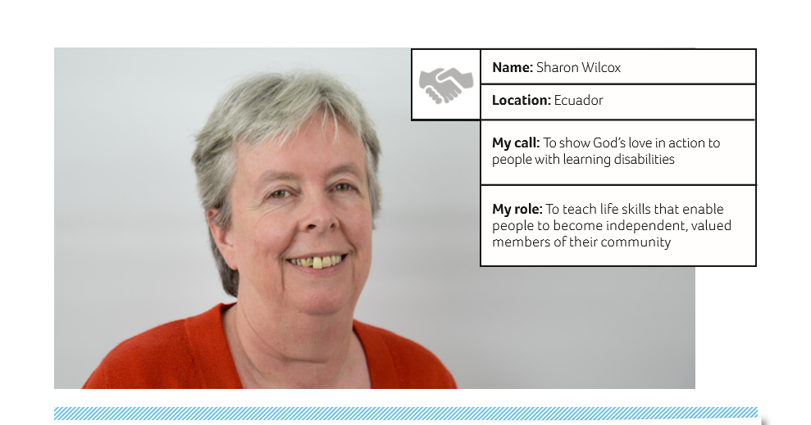

Dear friends,
Hello from Santo Domingo, at the end of what has been quite a dry summer. Quite a lot has happened since I last wrote.
The Orchid celebrated its first anniversary at the end of May by way of a visit to ‘Greenfrost’ for yogurt ice cream with fruit. This was very welcome, given the heat. Our gardening project has gone well and our crop of coriander was so popular that we have had to sow more. People were asking to buy it on the bus, and then the owner of the nearby grocery store called out to us to say that she would take as much as we could let her have. The look on everyone’s faces was sheer amazement that she wanted something that THEY had grown. It was very good – organic culantro (they tell me the seeds are coriander and the green leaves are culantro). We have also recently harvested carrots, camomile and basil.
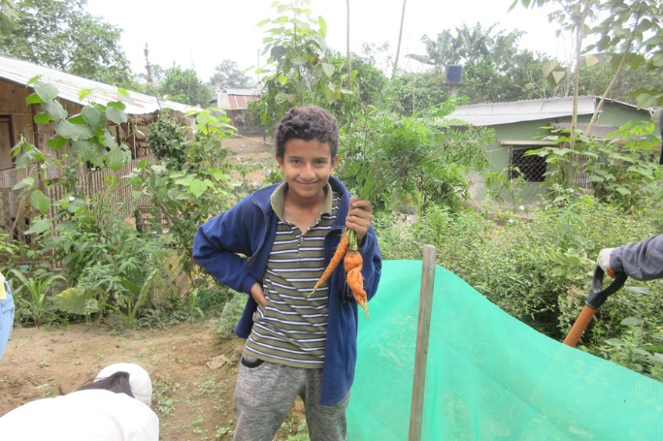Cristian with the first fruits 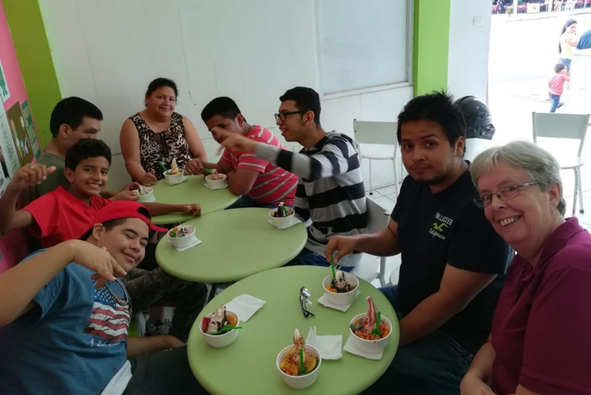The first anniversary
We celebrated Marlon’s birthday in June at the garden project, with more English style party food – crisps, sausage rolls, Ritz crackers, marshmallows and biscuits, along with the customary cola!
For a week in June and a week in July, my friends Peri and Ricardo had mission teams from the USA visiting them to run outreach events and I was able to help with these on a couple of afternoons each week. It was a real blessing to be able to pray with/for people. The Orchid was invited to join them on the Tuesday mornings, when I did a presentation of our work and the youngsters were able to demonstrate and sell some of the things we have been making. Each of them enjoyed the interaction and Jostyn did an unplanned rap song for them which had everyone clapping along.
Then in July the Latin Link Step Team arrived to work on the church where we are based. The idea was to help a local “maestro” build three classrooms upstairs. Well, they got the beams in place but were unable to build the rooms as the church had not been able to acquire the necessary planning permission from the council. As I write, the work has still not been done.
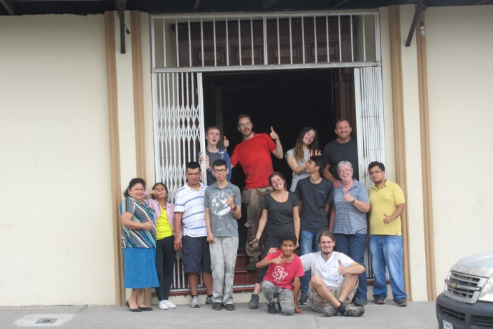With the Latin Link Step Team
So we moved out of the church to enable the team to start. The maestro’s mother kindly allowed us to use her house for three weeks (she is a member of the church). We had already decided that we were going to make “elevenses” for the group every day, so it was great to have a proper kitchen. What we had not bargained for was that one of the team had a nut allergy, another a gluten and lactose intolerance and yet another could not eat cheese. I am very pleased to say that nobody got ill as a result of our cooking (as far as I know).
We made fruit juices, milkshakes, empanadas, tortillas and a bean ceviche amongst other things. Everyone enjoyed making them (with the possible exception of Camilla, who really does not enjoy cooking). The Step Team seemed to enjoy their elevenses, with several of them saying that spending time with us at 11 was their favourite part of the day. Cristian certainly enjoyed spending time with one of them, and still talks about “the girl with the really blue eyes” (with a twinkle in his brown ones).
On 21 July, I was invited to attend the first graduation ceremony of students from Lydia and Mark Trezise’s card making project. It was great to see how the project has given them renewed hope for the future, as well as to celebrate their achievement.
August came and the Step Team left. The students, their mums and Gloria arranged a surprised birthday party for me, which was lovely. I wondered why Javier had turned up that morning with a tray of jellies (he didn’t know why). The following day Petita and I went on a bus trek to Lake Quilotoa up in the Andes. It is in the crater of a volcano. It was very windy, which made walking down to the lake very difficult and walking back up almost impossible. We managed about a quarter of the ascent, but then decided to do the rest on horseback. I had always said that I was never going to travel on horseback again, once was enough. However, the wind and the altitude made the decision for us.
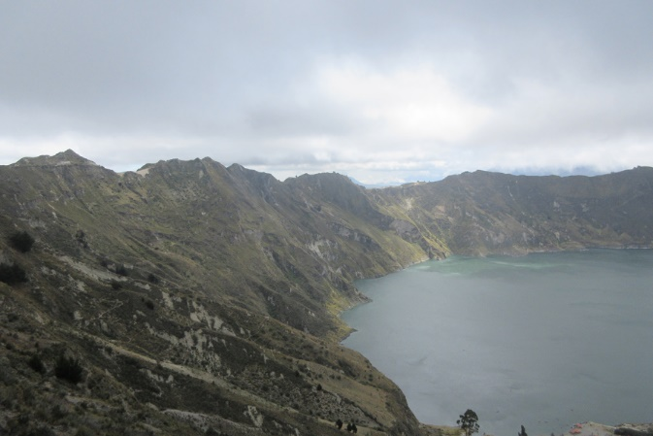Lake Quilotoa
The following week it was the Baptist church’s 50th anniversary and there were various events in the evenings. On the Friday it was a night of singing and dancing, and those of us at the Orchid were invited. Marlon and his dad sang two songs together, which was very moving.
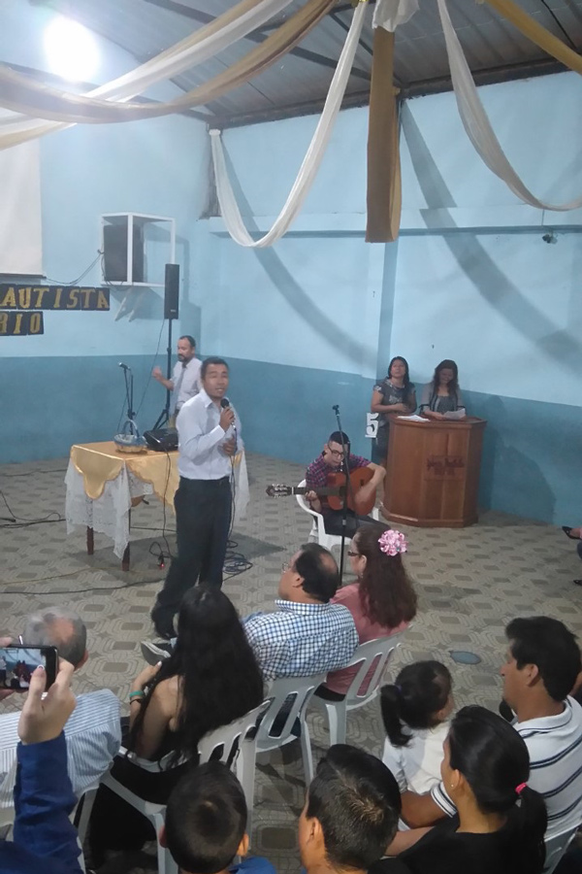Marlon and his dad 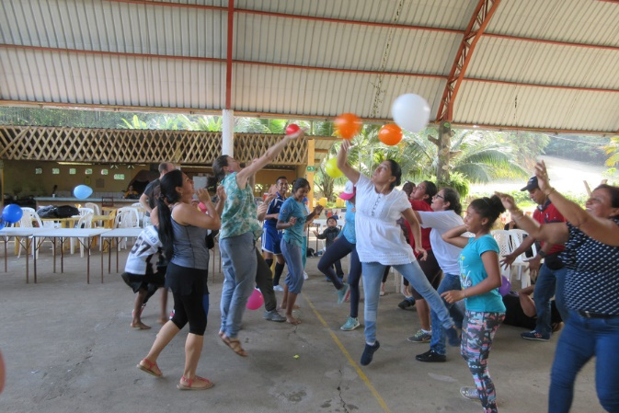The Baptist church’s anniversary games
On the Saturday we had a family day at local swimming pools. I was partly responsible for organising games and there were also football and volleyball competitions. The Sunday service was held in a local community centre, and lasted five hours! It culminated with a very large cake and an opportunity to wish happy birthday to Pastor William’s grandmother who had turned 100 at the beginning of September. She has been unwell, so it was lovely that she was able to be with us that day.
From 7 September we took two weeks holiday, half of which I spent planning and preparing classes; during the second week, I managed to get away for a few days at a place called Salinas which is south west of Santo Domingo. I saw a whale swimming off the coast, a colony of basking sea lions and some hungry pelicans. It truly is a wonderful country to visit.
When we returned from holiday, I heard that the Life in Abundance Foundation no longer wanted to have a day of integration with us every couple of months. This was as I had feared once Petita had left them.
I continue to be involved in visits to people from the church who are sick or housebound, taking them a bag of groceries from the fellowship and chatting and praying with them. We have also recently begun to see more and more Venezuelans coming to the church, as they flee their homeland looking for a better life. I really do wonder how dreadful things have become. Many of them have taken up jobs which has led to the locals saying “They have come here and are taking all our jobs”. Sound familiar?
On 4 October, I had to submit documents to renew my visa. I don’t know why but this is always stressful. It’s probably because every time you speak to the person in the office, they tell you that they need something different. This year was no exception. I found myself having to travel to the national police centre in Quito in order to get a criminal record check. I got one online for my old passport, but they had no record of my current one. I went on 13 September to give myself plenty of time and waited in line for an hour to be given an appointment, only to be told that they had no appointments for that day. In fact, I was told that there were no appointments available until 6 November due to the volume of people from Venezuela applying for visas. I explained that my deadline was 4 October, so they said: “well you could come on 3 October at 6am and queue again, and maybe you can get an appointment for the afternoon.”
Disheartened, I returned to the visa office in Santo Domingo. As I was telling the woman of my plight, her boss appeared (only God!). He sat with us, went through all my documents and said that as far as he could see, I probably didn’t need a criminal record check, as other documents from the migration department showed that the police were not looking for me and I was not banned from entering or leaving the country.
On 4 October, I submitted what I had. There is currently a 70 day wait for visas such is their workload. Usually it takes around 10-12 days. So I will get the visa in December; if not I will be home for Christmas.
Thank you for all your support. Visa permitting I hope to be able to visit some of you in March/April next year.
Every blessing,

Sharon

You can give online to Sharon at: churchmissionsociety.org/wilcox

Contact details: sharon.wilcox@hotmail.co.uk

